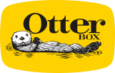

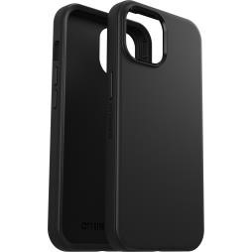
- Ultra-sleek design
SYMMETRY SERIES
/
iPhone 15, iPhone 14, iPhone 13
Product Description
/
You
don’t
have
to
choose
between
a
protective
case
and
a
stylish
one
.
Symmetry
Series
is
the
sleek
and
protective
case
that
shows
off
your
style
.
All
your
phone’s
buttons,
features
and
functions
work
flawlessly
.
And
Symmetry
Series
is
easy
to
remove
and
install
.
Symmetry
Series
is
the
slim,
trendy
case
that
delivers
trusted
OtterBox
protection
.
Features
/
Black
77
-
)
92636 (
Retail
- DROP+ | 3X as many drops as military standard (MIL-STD-810G 516.6)
- Raised edges protect camera and screen
• • •  • | Works with wireless and MagSafe charging pads (no magnets in case)  Made with more than 50% recycled plastic  5G compatible materials  Hassle-free customer service | 840304730278  77-94122 (ProPack)  840304745333

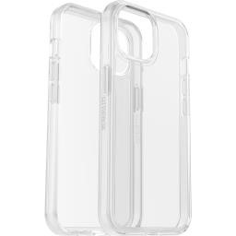
Tech Specs /
Product Name: Symmetry Series
Device Compatibility: Apple iPhone 15, iPhone 14, iPhone 13
Unit Dimensions: 6.02 x 3.11 x 0.53 in | 15.29 x 7.91 x 1.33 cm
Unit Weight:  Master Carton Quantity: | 0.08 lbs | 35.42 g  0.09 lbs | 38.71 g (Clear)  24 (Retail) | 20 (ProPack)  4.16-lb | 1885.08-g (Retail) | Clear  77-92668 (Retail)  840304730599  77-92674 (ProPack)  840304730650
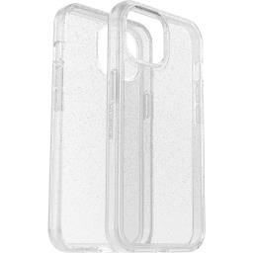
2.87-lb | 1301.40-g (ProPack) Master Carton Weight:
4.33-lb | 1964.04-g (Retail - Clear)
3.01-lb | 1367.20-g (ProPack - Clear)
14.63 x 9.19 x 5.13-in | 37.16 x 23.34 x 13.03-cm (Retail) Master Carton Dimensions:
11.81 x 9.81 x 7.63-in | 30.00 x 24.92 x 19.37-cm (ProPack) Retail Carton Dimensions: 7.75 x 4.25 x 0.70-in | 19.68 x 10.79 x 1.78-cm

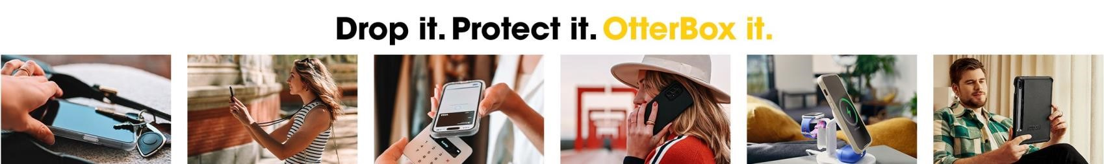
Claims /
DROP PLUS TESTED:  5G COMPATIBLE:  RECYCLED MATERIAL: | 3X  Yes Yes | Stardust  77-92669 (Retail)  840304730605
WIRELESS CHARGING COMPATIBLE: Yes
RECYCLABLE RETAIL PACKAGING: Yes
©2023 Otter Products, LLC. All rights reserved. The OtterBox name and OtterBox trademarks are the property of Otter Products,LLC, registered in the U.S. and other countries. All other trademarks are the property of their respective owners.

