* Ultra-sleek design

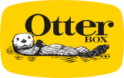

**SYMMETRY SERIES**

**/**

iPhone 15, iPhone 14, iPhone 13

**Product Description**

**/**

You

don’t

have

to

choose

between

a

protective

case

and

a

stylish

one

.

Symmetry

Series

is

the

sleek

and

protective

case

that

shows

off

your

style

.

All

your

phone’s

buttons,

features

and

functions

work

flawlessly

.

And

Symmetry

Series

is

easy

to

remove

and

install

.

Symmetry

Series

is

the

slim,

trendy

case

that

delivers

trusted

OtterBox

protection

.

**Features**

/

Black

77

-

)

92636 (

Retail

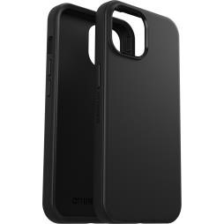

* DROP+ | 3X as many drops as military standard (MIL-STD-810G 516.6)
* Raised edges protect camera and screen

|  |  |  |
| --- | --- | --- |
| • • •  • | Works with wireless and MagSafe charging pads (no magnets in case)  Made with more than 50% recycled plastic  5G compatible materials  Hassle-free customer service | 840304730278  77-94122 (ProPack)  840304745333 |

# Tech Specs /

**Product Name:** Symmetry Series

**Device Compatibility:** Apple iPhone 15, iPhone 14, iPhone 13

**Unit Dimensions:** 6.02 x 3.11 x 0.53 in | 15.29 x 7.91 x 1.33 cm

|  |  |  |
| --- | --- | --- |
| **Unit Weight:**  **Master Carton Quantity:** | 0.08 lbs | 35.42 g  0.09 lbs | 38.71 g (Clear)  24 (Retail) | 20 (ProPack)  4.16-lb | 1885.08-g (Retail) | Clear  77-92668 (Retail)  840304730599  77-92674 (ProPack)  840304730650 |

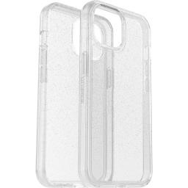2.87-lb | 1301.40-g (ProPack) **Master Carton Weight:**

4.33-lb | 1964.04-g (Retail - Clear)

3.01-lb | 1367.20-g (ProPack - Clear)

14.63 x 9.19 x 5.13-in | 37.16 x 23.34 x 13.03-cm (Retail) **Master Carton Dimensions:**

11.81 x 9.81 x 7.63-in | 30.00 x 24.92 x 19.37-cm (ProPack) **Retail Carton Dimensions:** 7.75 x 4.25 x 0.70-in | 19.68 x 10.79 x 1.78-cm

# Claims /

|  |  |  |
| --- | --- | --- |
| **DROP PLUS TESTED:**  **5G COMPATIBLE:**  **RECYCLED MATERIAL:** | 3X  Yes Yes | Stardust  77-92669 (Retail)  840304730605 |

**WIRELESS CHARGING COMPATIBLE:** Yes

**RECYCLABLE RETAIL PACKAGING:** Yes

©2023 Otter Products, LLC. All rights reserved. The OtterBox name and OtterBox trademarks are the property of Otter Products,LLC, registered in the U.S. and other countries. All other trademarks are the property of their respective owners.